**Mensuration**

**MENSURATION**

MATHS

1. Area of polygons:
   1. Area of a rectangle = Length  Breadth
   2. Area of a square = (Side)2
   3. Area of a triangle = 1

2

* Base  Height
  1. Area of a parallelogram = Base  Height
  2. Area of a trapezium =

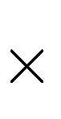

2

1

2

* 1. Area of a rhombus =

sum of parallel sides  distance between them

product of its diagonals



1

* 1. Area of a general quadrilateral can be found by dividing it into two triangles, by drawing on of its diagonals, and then applying the formula of area of a triangle.

1. Area of a polygon (or field) can be calculated by suitably dividing it into triangle, rectangle, trapezium etc.
2. Surface area of a solid is the sum of the areas of all its faces.
3. Amount of region occupied by a solid is called its volume.
4. For a cuboid of length l, breadth b and height h, we have:
   1. Volume of cuboid = (l  b  h) cubic units
   2. Total surface area of cuboid = (lb + bh + lh) sq units
   3. Lateral surface area of cuboid = {2(l + b)  h] sq units
   4. Diagonal of cuboid = units

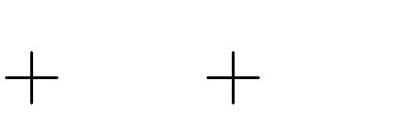

l2 b2 h2

1. For a cube of side a, we have:
   1. Volume of cube = (a3) cubic units
   2. Total surface area of cube = (6a2) sq units
   3. Lateral surface area of cube = (4a2) sq units
   4. Diagonal of cube = 3a units
2. For a cylinder of height h and base radius r, we have:
   1. Volume of cylinder = ( 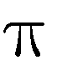r2h) cubic units
   2. Curved surface area of cylinder = (2 rh) sq units
   3. Total surface area of cylinder = 2 r (h + r) sq units
3. Unit conversion:
   1. 1 cm3 = 1 mL
   2. 1 L = 1000 cm3

iii. 1 m3 = 106 cm3 = 1000 L